**  
Database Access**

Database Access gives you ability to run different reports in **Entrapass Global Edition** and **Entrapass Global Edition hattrix** using a variety of tools (the list of tools that can be used can be found under Sybase web site).

Kantech will support on Crystal Reports as a tool.

A Crystal Reports Driver will be included in EPGE 5.02 installation folder (will be installed at the Crystal Reports machine to interface with the Sybase database).

The Database Access feature is a free option (**one and unique option can be activated in the system**) included in EPGE 5.02, that needs to be activated in the software.

Database Access **cannot** be installed in the same machine as the Entrapass (because Database Access acts as a Mirror Database).

**Installation steps:**

1. Activate the Database Access option:

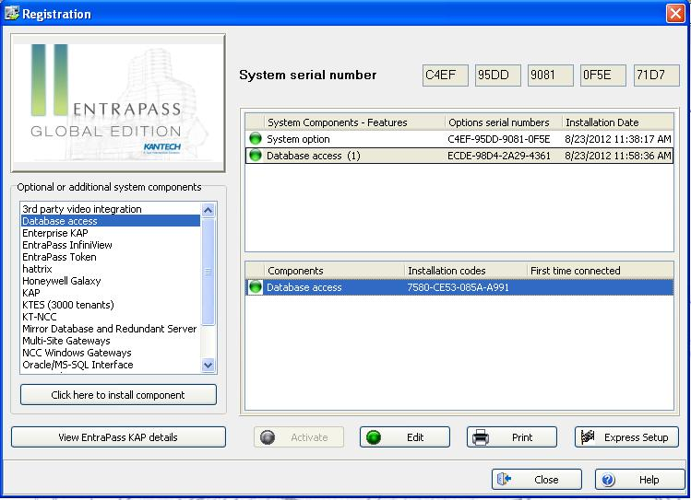



1. After you activate the option in EPGE 5.02, you need to complete the following steps in Entrapass:

2.1- Under: Devices – Application – Database Access – Database Access, setup a password for the operator **adssys**.

This is the default operator that has full access to the **views** and **tables** in the Sybase Advantage Database and Crystal Reports.

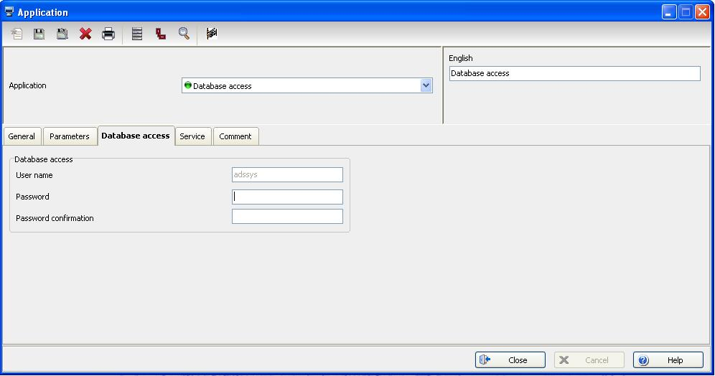

2.2- Under: System – Operator – Security, check the box: Create login name in external SQL database Access.

This operation will allow the Entrapass operator to get access to the **views only** in the Data Architect and Crystal Reports.

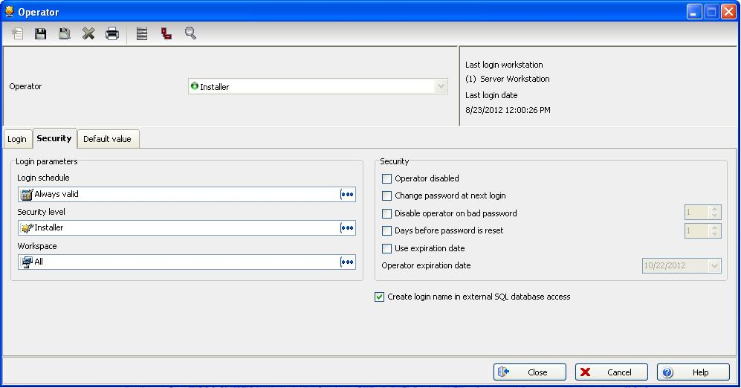

1. Install the Database Access:

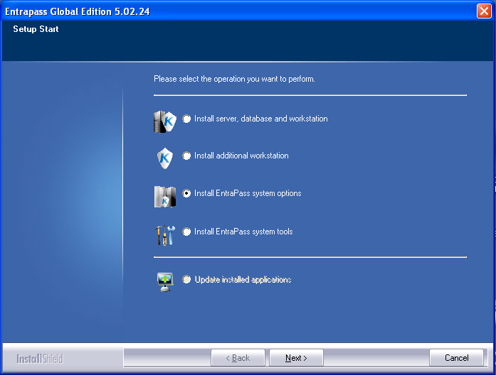

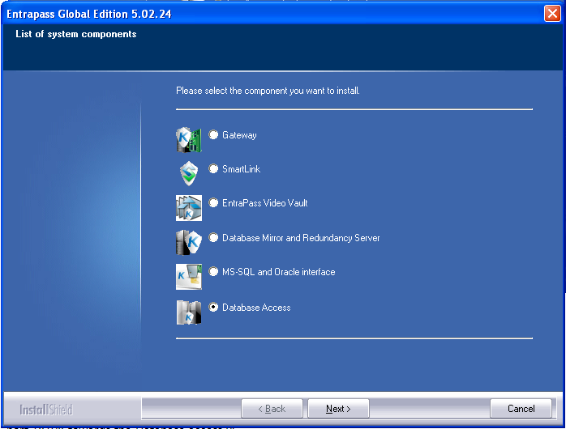

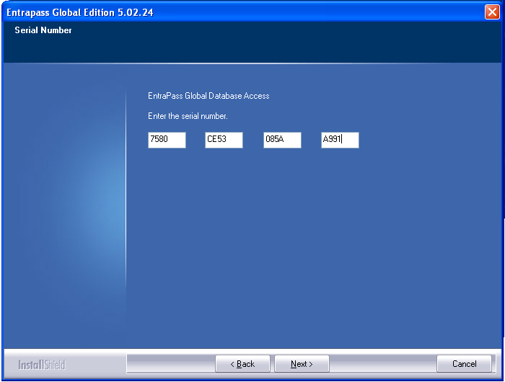

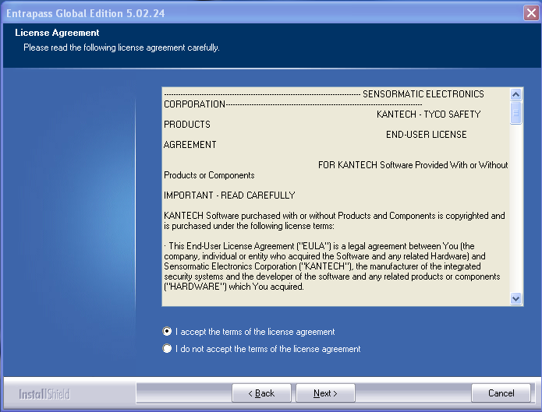

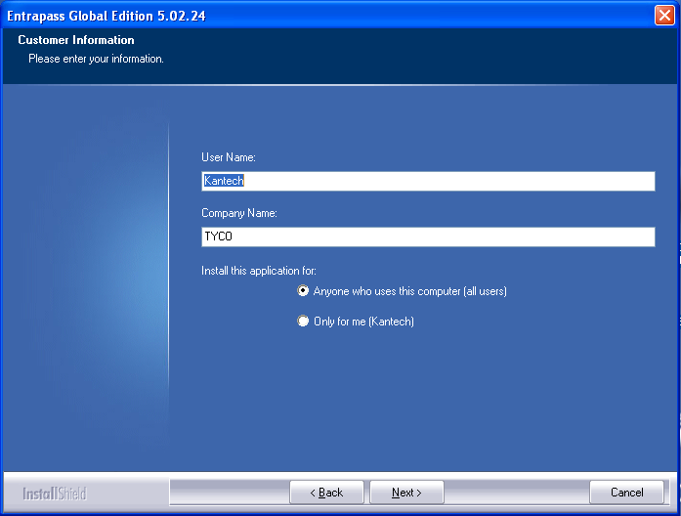

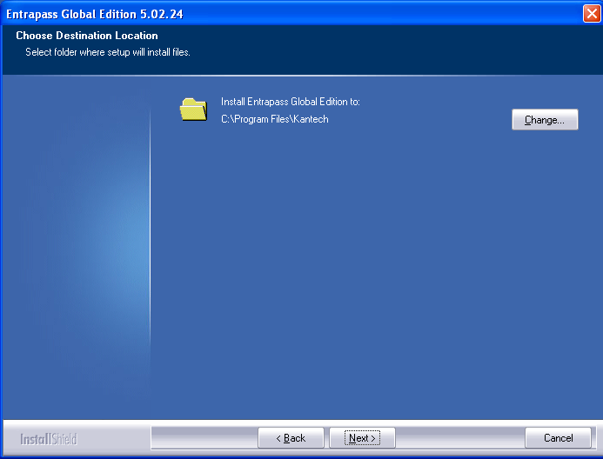

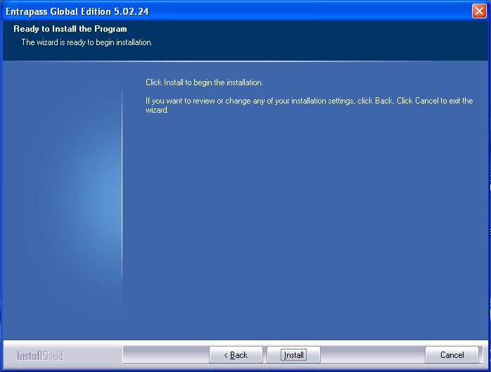

During the Database Access installation, a Sybase Advantage Database Server with a serial number of: 8128375 is installed in background (transparent for the installer).

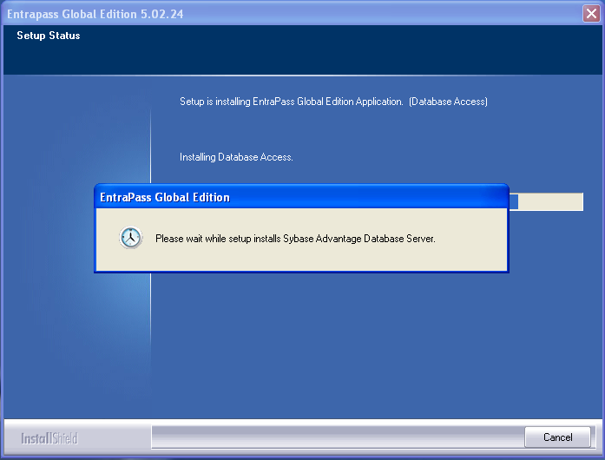

Make sure that there is no other Sybase Advantage Database Server installed in the same network.

If yes, you will get the following error.

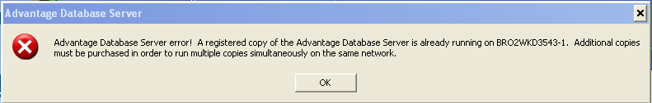

If the client wants an additional Sybase Advantage Database Server, he needs to buy a new license from Sybase.

Sybase Advantage Database Server needs to be installed manually from the EPGE installation folder: **Install\adswin_x86_32\Setup.exe**

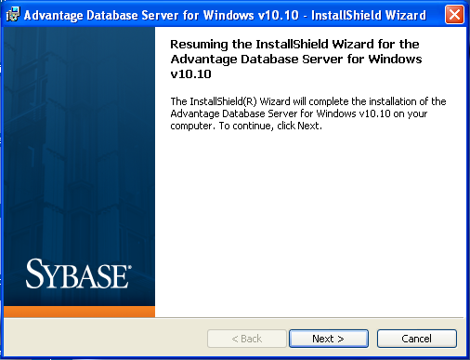

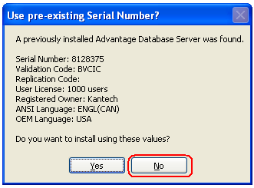

Enter your new Sybase Advantage Database Server license number

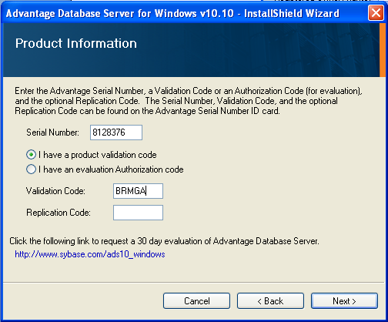

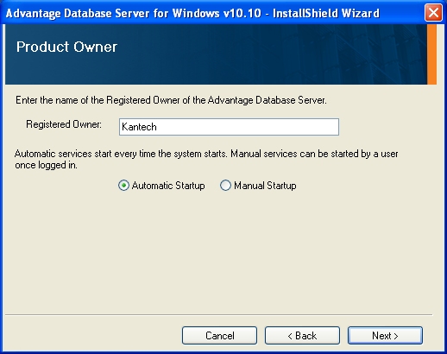

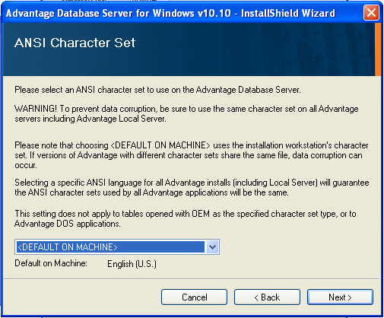

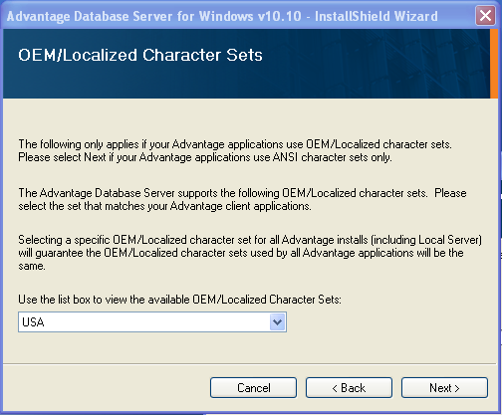

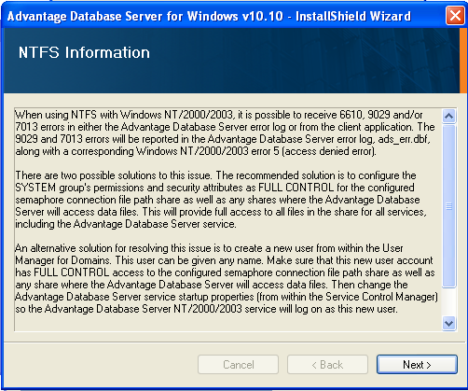

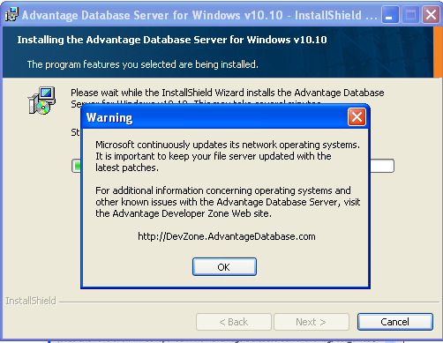

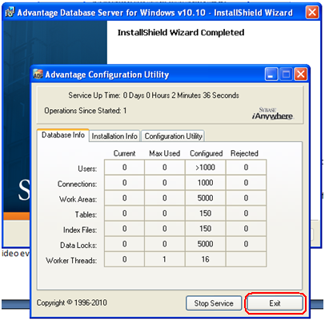

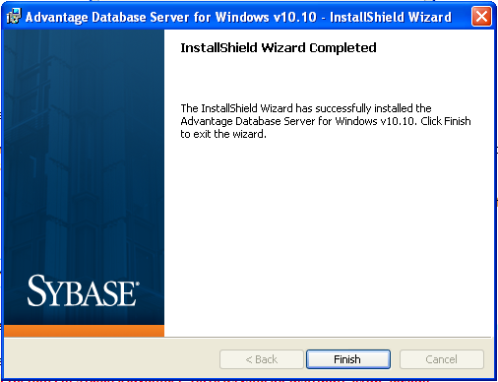

1. The authentication port for the Database Access is **18113**.

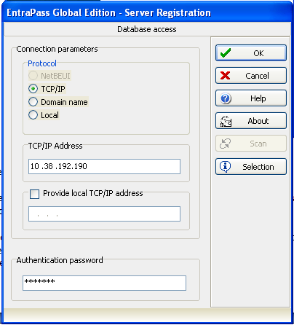

A WAN link can be performed by forwarding port **18000** towards the server (valid for applications) and port **18108** towards the Database access PC.

After the Database Access installation, it connects to the server, and makes a complete copy of the database (Archives, IN/OUT, Video events).

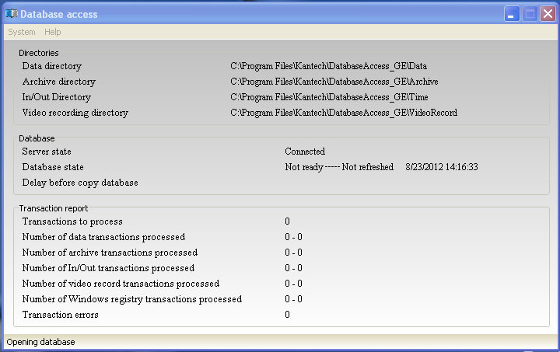

After the database is copied from the server, files are merged to one file:

**C:\Program Files\kantech\DatabaseAccess_GE\Data**

Archives files are merged to one files named: **Archives.adt**

IN/OUT files are merged to one file named: **Time.adt**

Video events files are merged to one file named: **VideoRecord.adt**

1. Crystal Reports Server can be installed in the same machine as the Database Access or in a different machine.

5.1- Chrystal reports installation:

A 30 days evaluation version can be downloaded from Crystal Reports web site: <http://www.crystalreports.com/>

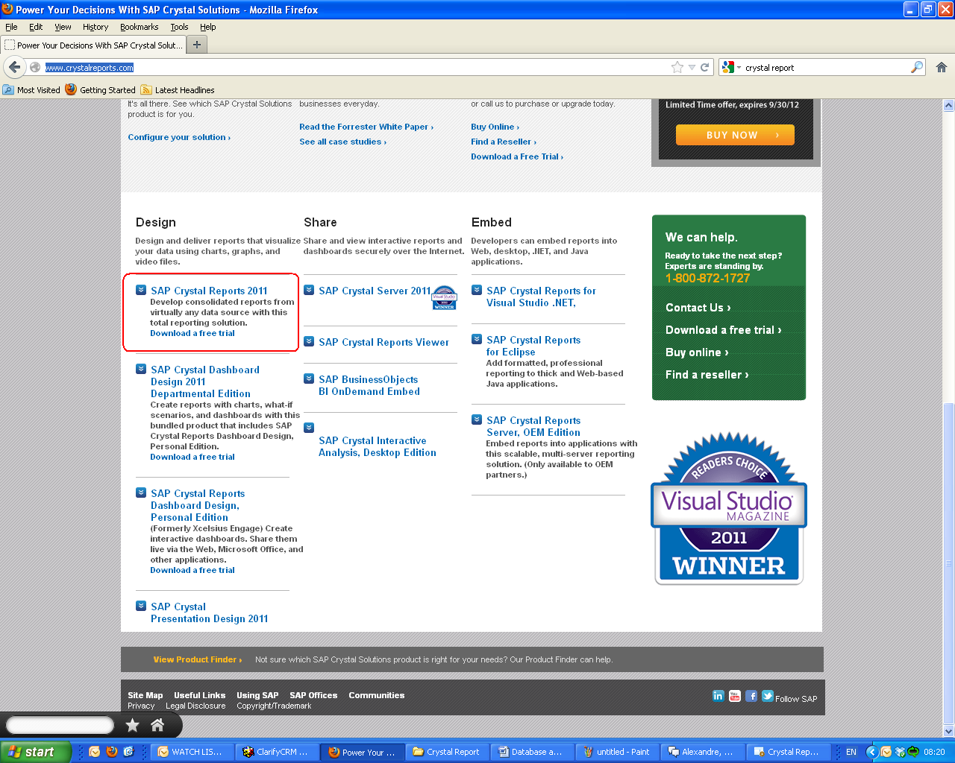

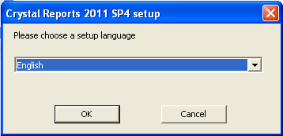

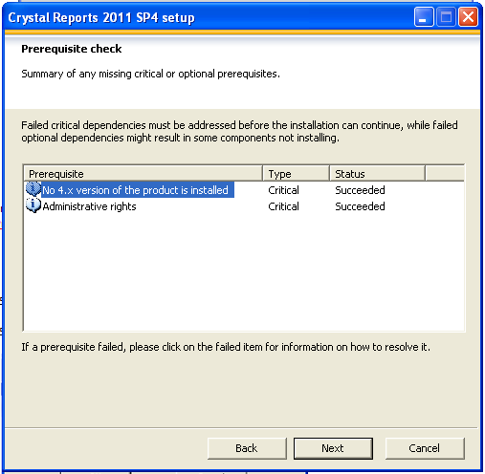

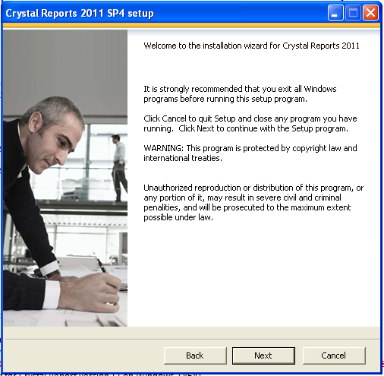

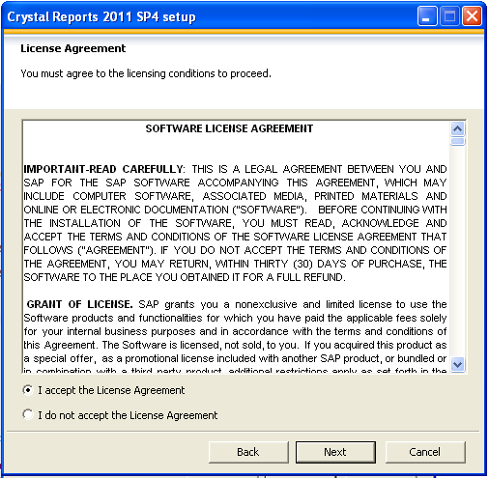

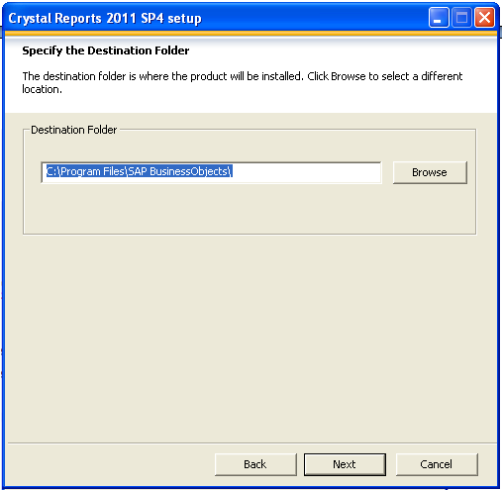

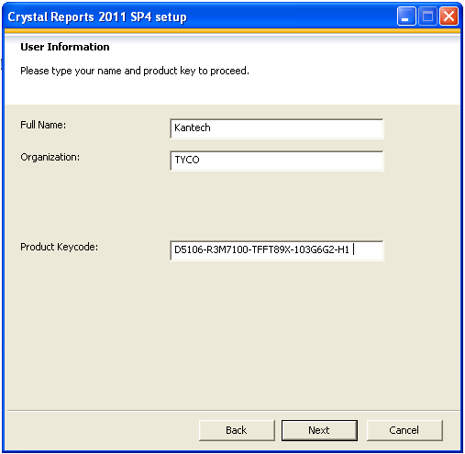

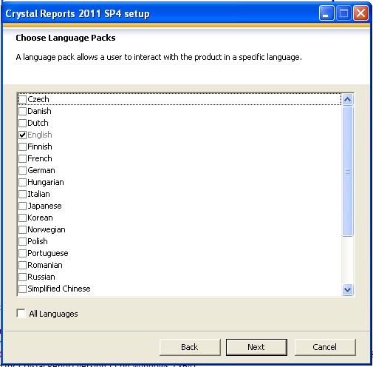

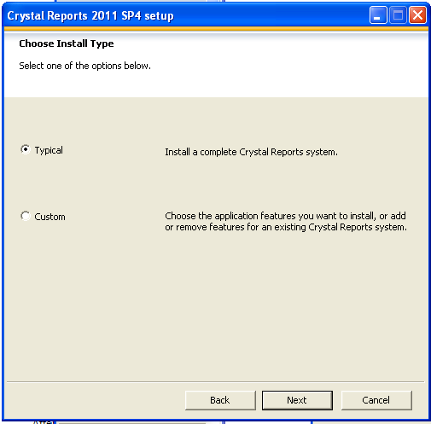

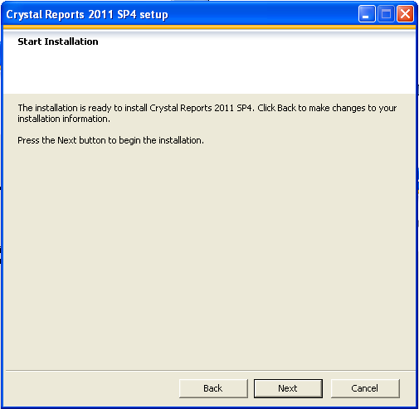

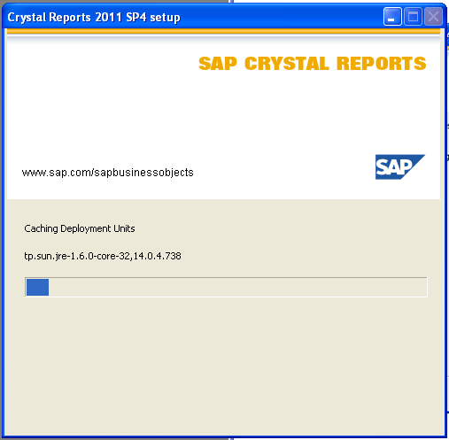

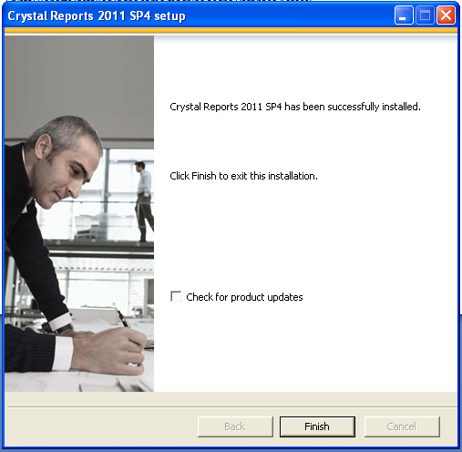

5.2- Crystal reports driver installation:

The driver can be found under the EPGE installation folder:

EPGE 5.02.24\Install\Sybase\crystal.exe

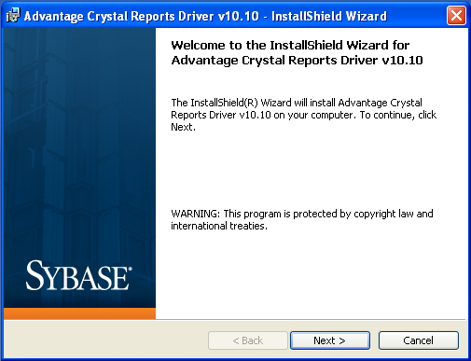

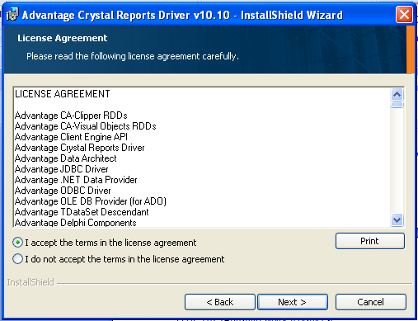

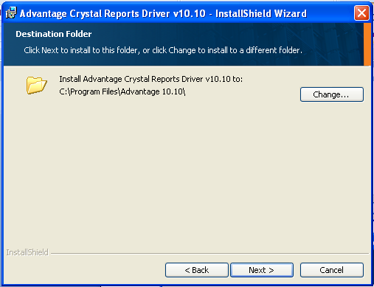

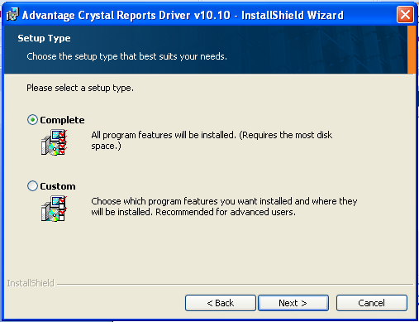

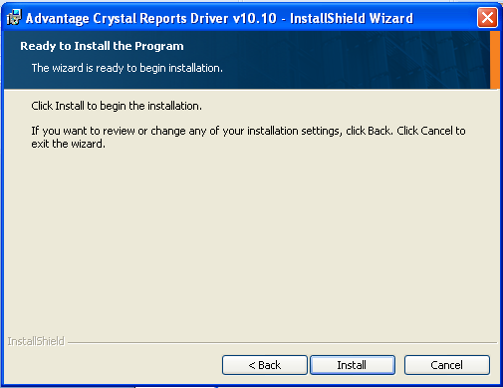

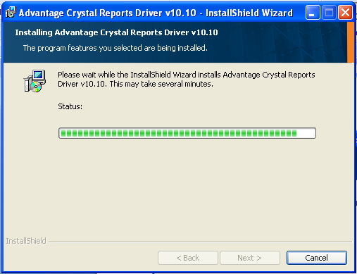

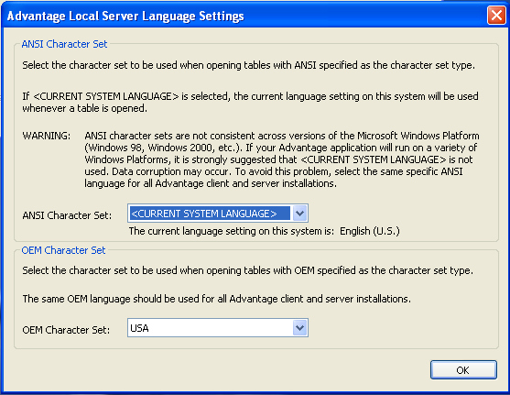

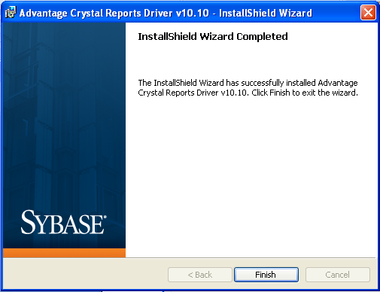

After Crystal Reports installation, a DLL needs to be manually moved:

From: **C:\Program Files (x86)\Advantage 10.10\Crystal\Redistribute\crdb_ads.dll**

To: **C:\Program Files (x86)\SAP BusinessObjects\SAP BusinessObjects Enterprise XI 4.0\win32_x86** (Path for Crystal Reports version 11 on Windows 7 x64)

1. Connect Advantage Data Architect to the Database Access:

6.1- Crystal Reports installed in the same machine as the Database Access:

Open Database Data Architect 10.10

Username: Kantech

Password: Kantech

**With the operator login you will have access to the database Views only.**

**To have access to the database Views and Table, you must use the operator: adssys.**

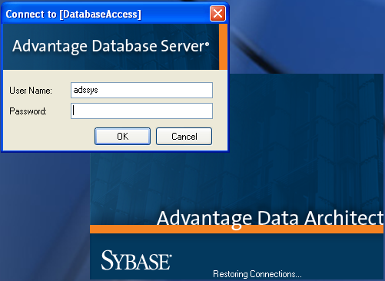

A default connection to the Database Access already exists.

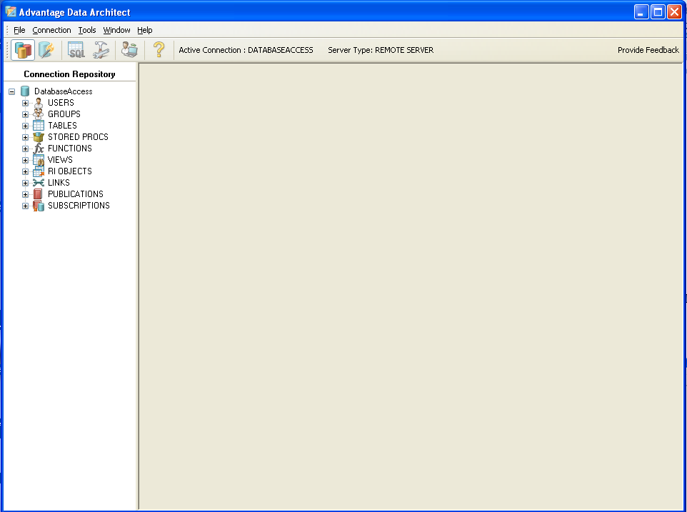

6.2- Crystal Reports installed in a different machine then the Database Access:

Two additional steps needs to be completed:

Install Data Architect.

Connect Data Architect to the Database Access.

Open Database Data Architect 10.10 – Connection – new connection wizard – create c connection to existing dictionary.

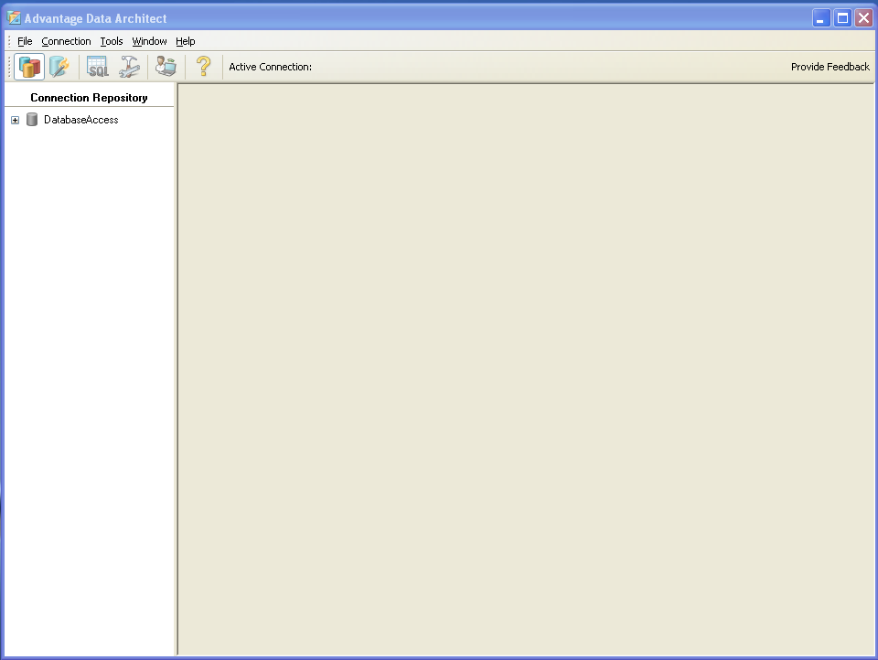

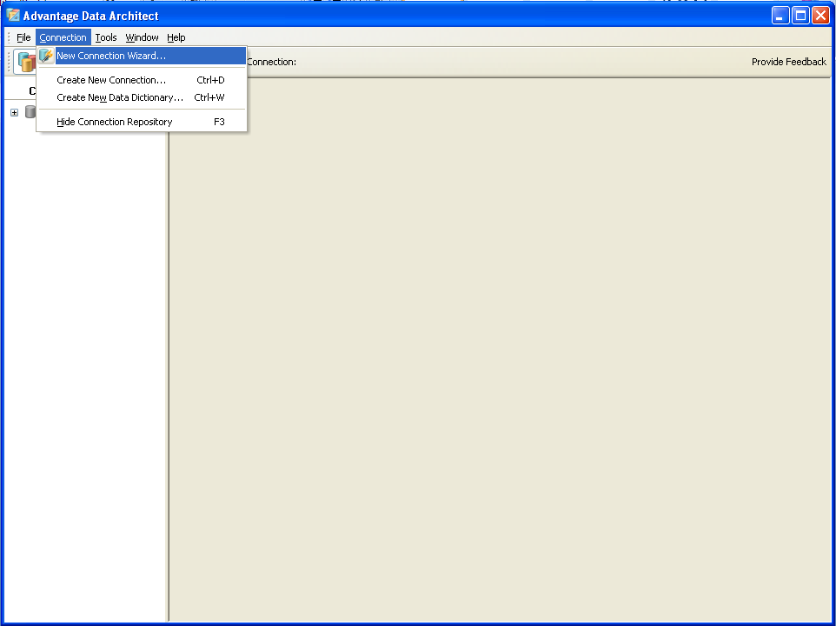

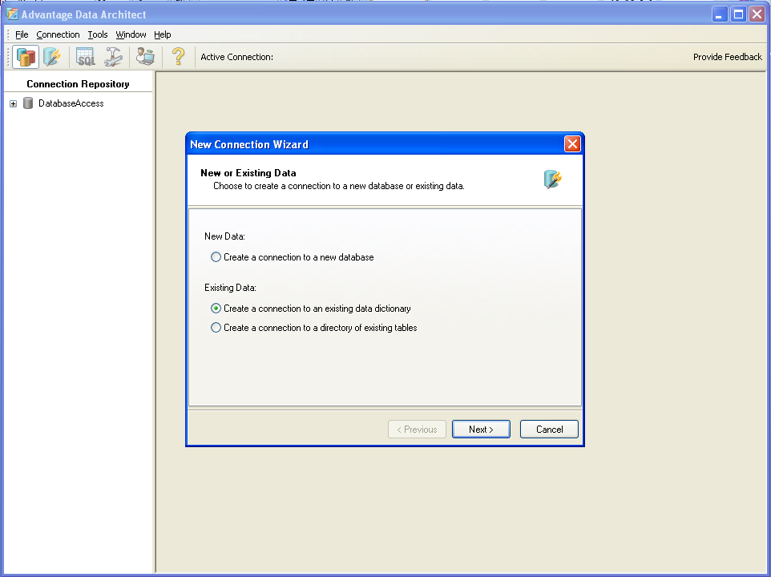

Database name: Give it a name

Connection path: **\\Database** **Access computer name\databaseaccess\databaseaccess.add**

Server type: remote

Username: Kantech

Password: Kantech

**With the operator login you will have access to the database Views only.**

**To have access to the database Views and Table, you must use the operator: adssys.**

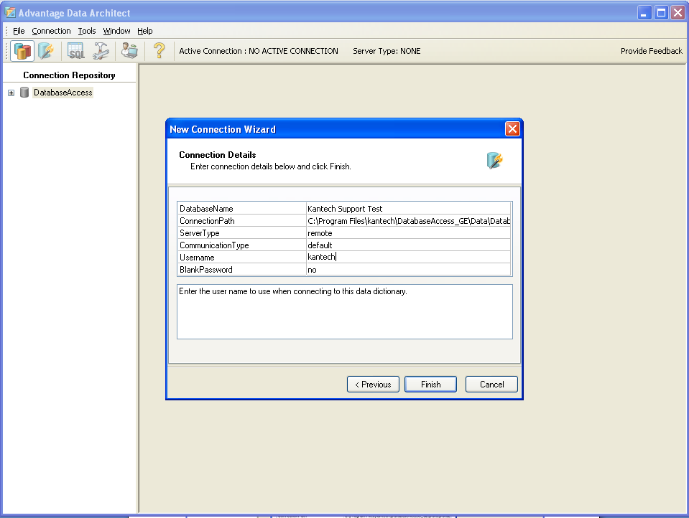

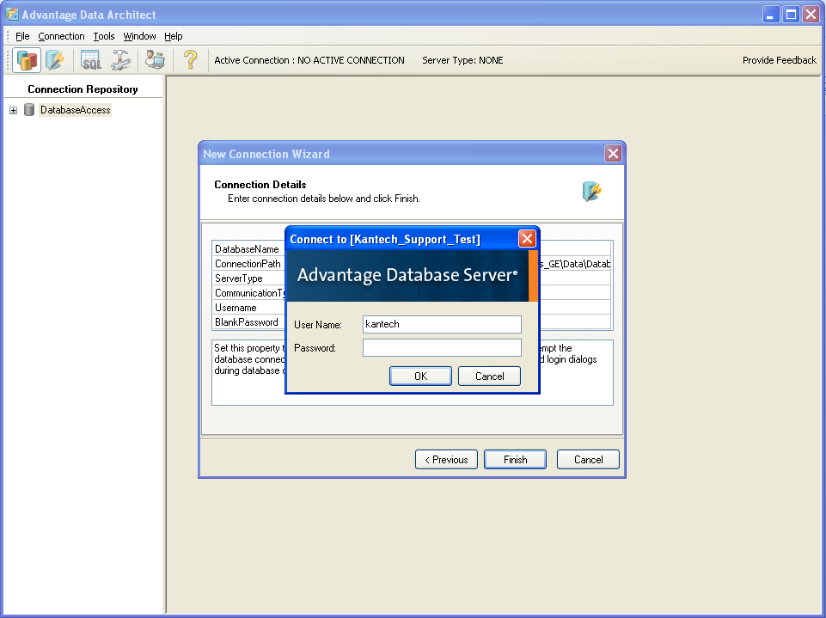

In your database connection properties, make sure that the collation is set to:

**general_vfp_ci_as_1252**

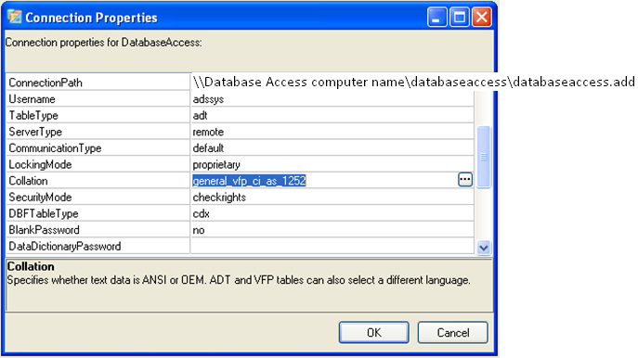

1. As a last step, open Crystal Reports:

To run reports through Crystal reports

New – using report wizard – create new connection – expand Advantage – select the database – next – enter the Entrapass operator login name and password.

1. Report wizard.
2. Create new connection.
3. Advantage.
4. Select the database source name.
5. Next.

Enter the database username and password.

