Setting up the MS-SQL Card Gateway with EntraPass Corporate/Global

The purpose of this application note is to configure the MS-SQL Card Gateway using a MS-SQL Server in order to have it work with EntraPass Corporate Edition or EntraPass Global Edition.

Table of Contents:
Requirements…………………………………………………………………………………………1
Initial Setup……………………………………………………………………………………………1
Insertion commands information...………………...……………………………………………….4
Card Gateway Test Application…………………………………………………………………….5
Advanced Query Programming and SQL Query Analyzer………………………………………6

Requirements:
- EntraPass Corporate Edition (version 3.10 and above) or EntraPass Global Edition (version 3.11 and above) installed.
- Oracle/MS-SQL Card interface option code registered and activated
- Oracle/MS-SQL Card interface must be installed on the MS-SQL server or a computer with a MS-SQL client.
- LAN connection with the EntraPass software, the MS-SQL Server and Oracle/MS-SQL Card interface.
- MS-SQL system administrator password.
- IT must have created the database in the Ms-SQL Server.

Initial Setup:

-DLL for 2005, compatibility mode
-Client components on card gateway computer

From the EntraPass workstation, under Devices/EntraPass application, choose the Oracle/MS-SQL Interface and go to the Oracle/MS-SQL interface tab. (see Fig 1)
- The Database type is the type of Database engine you will use. Note that if you are using the Oracle 9i or 10i you will need to select Oracle 8.
- The Server name is the PC where the MS-SQL/Oracle Server is located (BRO1WDK250/SQL_SRV).
- The Database name is the name of the database in the MS-SQL/Oracle.
- The Oracle Data File is ONLY used when an Oracle database is used.
- Administrator access for initialization needs to be checked for the first time setup. Enter the Administrator User name and Password of the MS-SQL Server.
- The Database Access is the EntraPass account that will be used by the MS-SQL/Oracle database to connect to the EntraPass Server. Please note that this account cannot be used by any other Workstation. Also, it is recommended to set the account as an installer account.

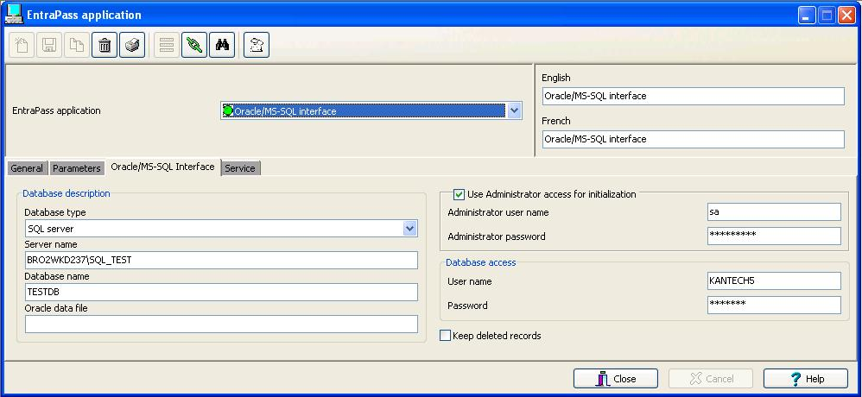
Figure 1

Go on the PC where the Card Gateway is installed and start the MS-SQL and Oracle Interface application located on: Start/Programs/EntraPass Corporate Edition/ MS-SQL and Oracle Interface/ for EntraPass Corporate edition or Start/Programs/EntraPass Global Edition/ MS-SQL and Oracle Interface/ for EntraPass Global edition. Every time the application starts, it will copy the database from the EntraPass Server to the Card Gateway application. Once the transfer is complete the following window will close. (See Fig. 2)

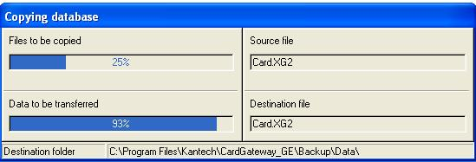

Figure 2

When the MS-SQL and Oracle Interface state is: Database is ready; it means that the Database is ready to be used. (See Fig. 3)

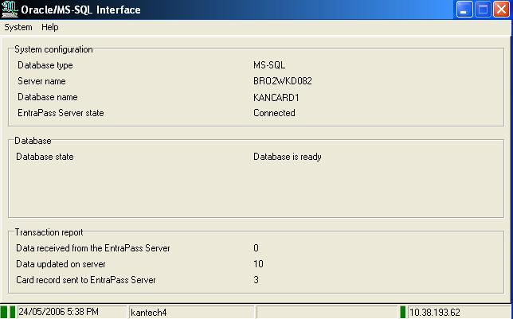

Figure 3

Please note that the below information is to be used for MS-SQL software or a third-party software.
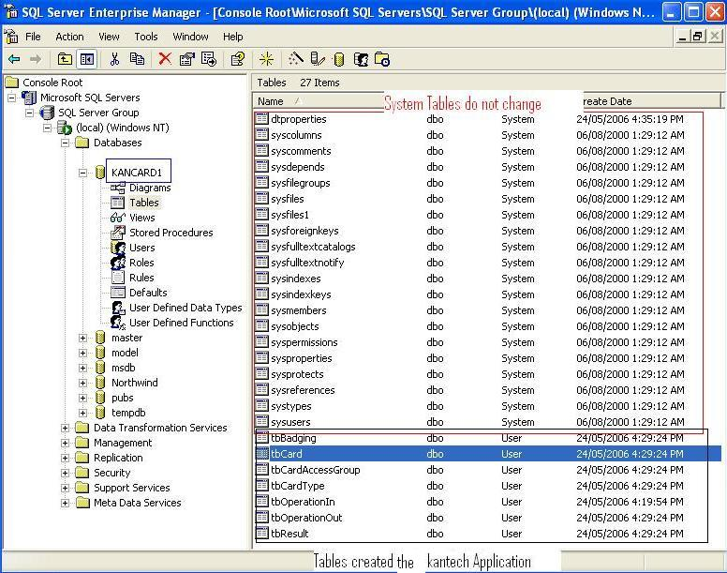
- In order to view the tables in the MS-SQL, Server open the Enterprise Manager located at: Start/Programs/Microsoft SQL/.

This is an example of how the MsSql database will look like.
Figure 4

In order to prevent database corruption, the MS-SQL tables should not be modified directly; queries and third party software must be used to make changes.
- The table TbOperationIn will always be empty if everything is communicating and this table will be constantly be scanned by the Card Gateway.
- The table TbOperationOut will list the valid create/modify/delete of the cards. This information is sent by the server. The table is emptied every time the MS-SQL/Oracle application or the EntraPass Server are communicating with each other.
- The table TbCard holds all the card information. This table is not scanned by the Card gateway, it is only updated.
- The table tbResult holds a description of all the valid and invalid commands. The table is emptied every time the MS-SQL/Oracle application or the EntraPass Server are communicating with each other.


Note that if the communication fails, the data in the table tbOperationIn will be buffered until the communication is restored. Please note that the pkIn field MUST be incremental Duplicate pkIn rows will not be accepted in the table, thus causing the information to be lost.

Insertion commands

In order to make a modification to the cards using the MS-SQL/Oracle database, we must use “insert commands” to insert new rows in the tbOperationIn table. This table will be scanned and then will update the EntraPass database. One of the most important fields is the CardOperation field. This field will determine what action the card gateway will perform on the card.

Possible CardOperation values:

Value | Description
0 | This request will allow creating a new card if the card does not exist or to modify the card if the card exists. In the two cases, at the end of the transaction, the card will contain only Information specified in the request .All the previous information will be deleted.
1 | This request will allow erasing a card if this it exists. If it does not exist the system will add a log to indicate that the request of deleting the card failed because the card does not exists.
2 | This request will allow creating a new card if the card does not exist or to modify the card if the card exists. Only fields in the request are updated, the remaining fields are not erased. If the card does not exist then it will be created. .
3 | This command will allow creating a card using the information of an existing one. Following the operation, the original card will be deleted. It will be therefore possible, to update fields using this operation. If the original card does not exist then no action will be taken and the system will generate an error.
4 | This command will allow creating a card using the information of an existing one. Following the operation, the original card will not be deleted. It will be therefore possible, to update fields using this operation. If the original card does not exist then no action will be taken and the system will generate an error.

Note: We must assign a unique numeric value to the field pkIn. The value itself does not matter as long as the software is communicating.

Card Gateway Test application
There is a test application that can be used to enter, modify or delete cards. This application may be used to show the SQL query that is needed to perform the task. In order to start the Test MS-SQL and Oracle application, go to Start/Programs/EntraPass Global Edition/ MS-SQL and Oracle Interface/ for Global Edition or Start/Programs/EntraPass Corporate Edition/ MS-SQL and Oracle Interface/ for Corporate

- The Test Application requires to be logged with the settings as the MS-SQL/Oracle card gateway. The following settings should be entered:
- The Driver name is the type of Database engine you will use. Note that if you are using the Oracle 9i or 10i, you need to choose Oracle 8.
- The Server name is the PC where the MS-SQL/Oracle application is located
- The Database name is the name of the database in the MS-SQL/Oracle.
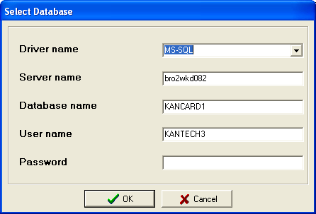
- The User name and Password is the EntraPass account used to login the Card Gateway.

Figure 5

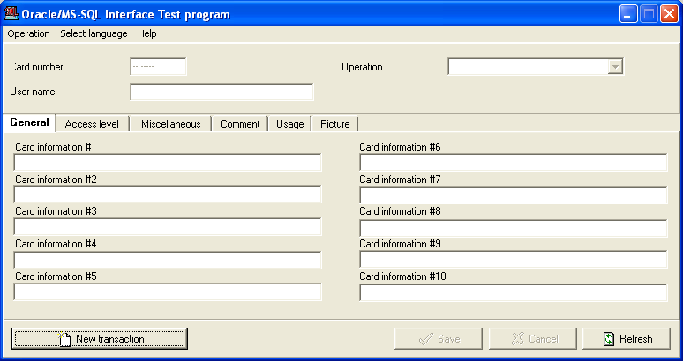
From the Oracle/MS-SQL Interface Test program we can create, delete and modify any card. We can also assign badges, access levels and card types but we cannot create new badges, access levels or card types. As in Figure 6, this is an example of Test Application Figure 6
Note: This application is for testing purposes only.

Advanced query programming
The below program should be used as for troubleshooting only since there is no error checking. As long as the query’s syntax is correct, MS-SQL will accept the command. This should be used at the user’s discretion and with an IT person present.

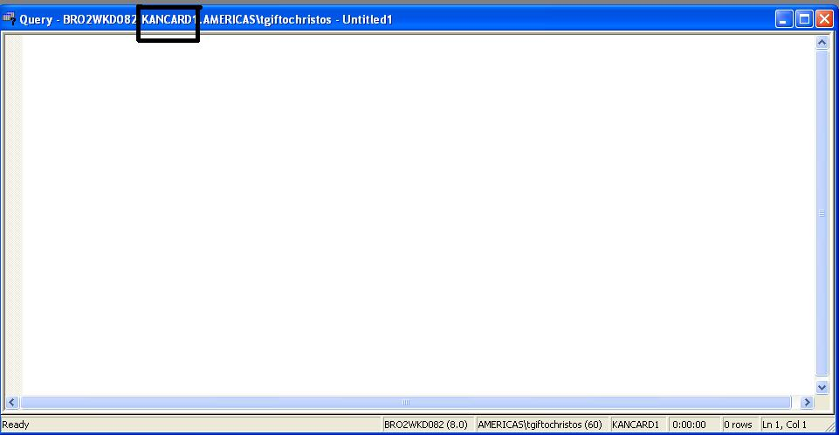
We may also use the MS-SQL interface to insert cards. From the MS-SQL side, once the Enterprise Manager is open, make sure you highlight the proper database and then go to Tools/SQL Query analyzer. A new program will open. You must make sure the title bar of the text window says the proper database name otherwise you are working on the wrong database. ( See Figure 7)

Figure 7

From this window we will be able to write SQL queries and execute them. Once the query is entered, press on the Play button on the main window. According to the amount of inserted commands, you typed you should see “(X row(s) affected)”. (See Figure 8)
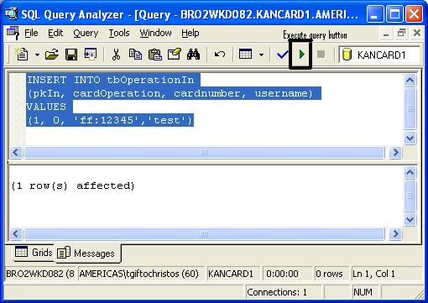

Figure 8

Prepared by: Tom Giftochristos mail: tgiftochristos@tycoint.com

Additional information
Making compatible an SQL 2005 with card gateway

Voici tel que convenu les détails du RDP 9600 qui explique comment faire fonctionner SQL 2005 avec Card Gateway :

1- Installer MS SQL Server Express 2005
2- Installer EPGE et Card Gateway
3- Configurer l'application Card Gateway dans Workstation
4- Remarquer le 1er message d'erreur : "Vendor initialization failed. Cannot load an IDAPI service library. File : NTWDBLIB.DLL. AliasL MasterDB"
5- Copier manuellement le fichier "NTWDBLIB.DLL" (trouvé dans google) dans le dossier C:\Windows\System32
6- Remarquer le 2e message d'erreur : "Cannot locate or connect to SQL server. Unable to connect : SQL Server is unavailable or does not exist. Unable to connect : SQL Server does not exist or network. General SQL error."
7- Modifier la BD Kancard et la mettre en mode compatible 2000
8- Voir que les tables se créent

